Name Total
20

1 Read and complete the table.
swim in the sea make a snowman go skiing
BEACH | MOUNTAIN

go surfing
go snowboarding collect pebbles go to a ski resort go fishing
8
Read and write. Use be going to.
- Mike (go) camping this summer.
2
- I (buy) a sleeping bag.
- Danny and Nora (not make) a snowman. There isn’t any snow.
- A: you (swim) in the lake?
B: Yes, we are.
- Sandra (not stay) in a hotel. She (sleep) in her tent.
- A: she (go) camping?
7
B: Yes, she is.

Listen and tick (4).
3

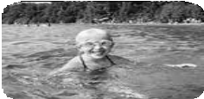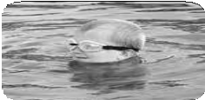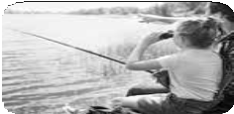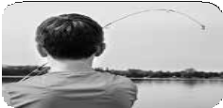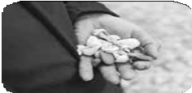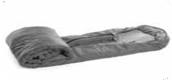1. 2.
a
b
c
a
b
c

2

Read the questions and answer about yourself.
Sure!
Great idea!
Sorry, I can’t.
4
- Would you like to go to the clothes shop? We can buy clothes.
3

- Would you like to go to the amusement park? We can go on a ride.

- Would you like to go to the stadium? We can watch a game.

