Name Total
20

Look and write the words.
1

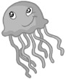
1.

2. 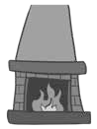
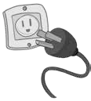
3.
4.

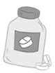
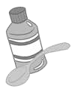
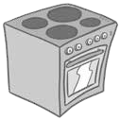
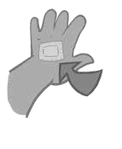
5.

6.

6
Read and write should or shouldn’t.
2
- Karen has got a fever. She go to the doctor.
- Jane, I’m bleeding. What I do?
- You go near the fire. It’s dangerous.
- It’s hot here in the sun. You put some sunscreen on.
- You put the medicine in the fridge. It’s very hot.
- A: I have got a sore throat.
B: You drink some warm tea.
6

Listen and number (1-4).
3
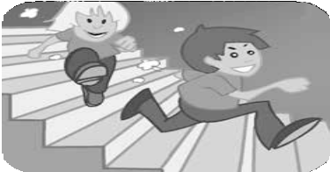
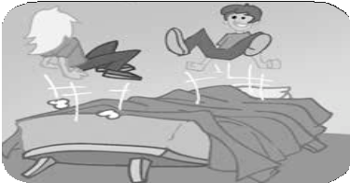
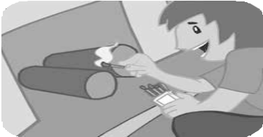
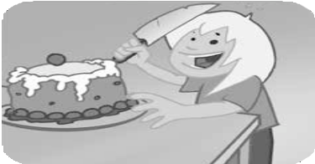
a
b
c
d
4

Write four things you should or shouldn’t do at school or at home.
4
1.
2.
3.
4
4.

