Name Total
20

Look and write the safety rules.
fasten / seat belt
cross / zebra crossing
wear / helmet
stick / head / window keep / hands / handlebars
1

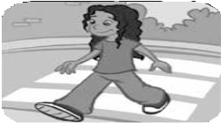
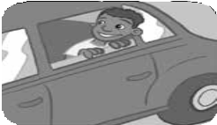1. 2.
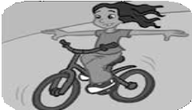3. 4. 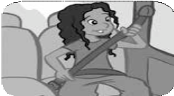
5

Listen and circle a, b or c.
2

- Where are they going?
a. cinema b. concert c. amusement park
- What time does the next bus leave? a. 10.30 b. 11.15 c. 11.30
- How much does the ticket cost? a. £5.20 b. £4.99 c. £5.99
- How are they going to get there?
a. by car b. by bus c. on foot

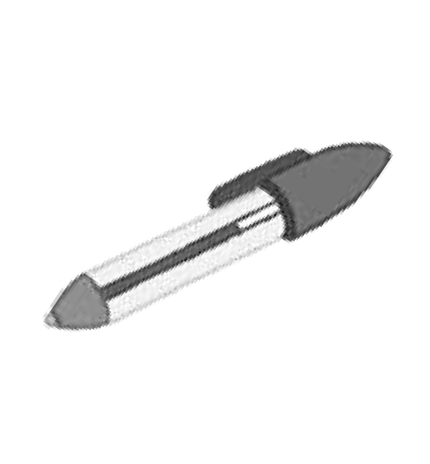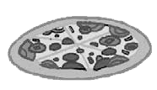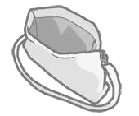3 Look and write. How much do they cost?
4
4.
5.
6.

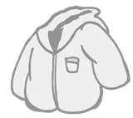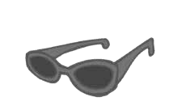1.
2.
3.
1.
2.
3.

4.
5.
6.

Complete with your ideas.
6
4
- Travelling by gondola is .
- Playing football is .
- Travelling by bus is .
- Going to school is .
5
- Going on holiday is .

