Name
40

Circle the odd word out.
1
Total

- headache toothache tent earache
- socket race matches stairs
- intelligent easy dinosaur heavy
4
- metre panda rhino gorilla

Circle the correct answer.
2
- Dinosaurs were very big. T. rex’s head was than a small car.
a. big b. bigger
- Dolphins are fish.
a. more intelligent than b. the most intelligent
- Elephants are rhinos.
a. heavier than b. the heaviest
- I think football is sport in the world.
a. the best b. better
- Ice hockey is one of sports in Canada.
a. more popular than b. the most popular
- Ice hockey is than baseball.
6
a. hard b. harder
Read and write. Use be going to.
3
- Tom (go) fishing in the lake.
- I (make) a snowman when we go to the mountains.
- A: Susan (play) in the park with her friends tomorrow?
B: Yes, she is.
- They (not watch) TV in the afternoon. They (play) cricket.
- He (read) a book at the weekend.
6

Listen and circle Yes or No.
4
- Bill is going to go camping. Yes No
- He is going there by bus. Yes No
- It takes seven hours by bus. Yes No
- The bus ticket is cheap. Yes No
5
- The bus leaves at 11.20. Yes No

Write the road safety rules.
5

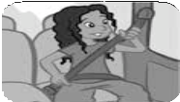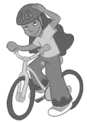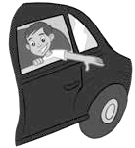 Always

1. 2.

3. 4.
4

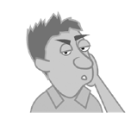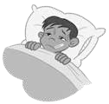6 What’s the matter with them? What should they do? Look and write.

- He has got . He should .
1.

- He has got . He should .
2.

- She has got . She should .
3.
6

Write sentences using –ing.
7
- ride / in tuk-tuks / fun
- travel / plane / comfortable
- go / motorbike / fun
3

Read and match.
8
- Would you like to go to the skatepark?
- Would you like to go to the stadium?
- Would you like to go to the beach?

  - Great idea! Let’s go swimming!
  - Sorry, I can’t.
  - Sure! Thank you!

3

Answer the questions about yourself.
9
    - Do you like riding your bike? Why?

    - Do you like watching TV? Why?

    - Do you like puppies? Why?

3

