Name Total
20

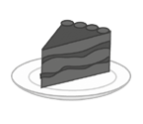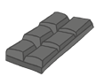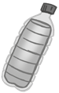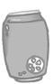1 Look and write.

- a of lemonade

- 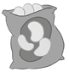 a of crisps

- a of orange juice
- a of chocolate

- a of cake

- a of water

6

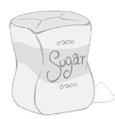
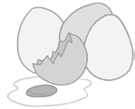
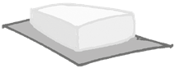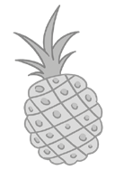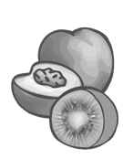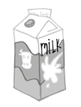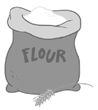Listen and circle what the children have.
3.
6.
7.
1.
2.
5.
2

4.

4
Read and write. Use a / an / some / any.
3
- We need flour, milk and butter for the pancakes.
- Mary wants apple, orange and pineapple for her fruit salad.
- Have you got kiwis in the bag?
- There isn’t juice in the fridge.
- There are spoons, plates and forks on the table, but there aren’t knives.
6
- Let’s buy carton of milk and boxes of cereal.

Answer about yourself.
4
- How many hours do you sleep every night?
- How much milk do you drink every day?
- How much chocolate do you eat every week?
- How many glasses of water do you drink every day?
4

