Name Total
20

Write the nationalities.
1
- the USA
- the UK
- Mexico

- Ukraine
- China
5

Read and write. Use the adverbs of frequency and the verbs in brackets.
2
usually always never sometimes

- Susan Sundays.
- The children
(go) to the ice-skating rink on

(play) chess at the weekend.

- I
- My father
(swim) in the summer.
(cook).
4

Listen and match.
3
- Jim is from Brazil and plays basketball on Saturday.
- Paola is from the UK and swims on Wednesday.
- Kelly is from the USA and plays chess on Sunday.
3

at are you doing?
4 Look and write.
Wh
1.
.

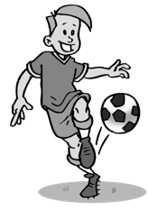
What is he doing? football.
3.
What is she doing?

2. her homework.

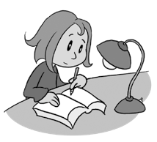
What are they doing?
.

4.
8

