Name Total
40

Circle the odd word out.
1
5
1. music | science | British | history
2. astronaut | author | garage | photographer
3. Mexico | Chinese | Korean | Brazilian
4. pyramid | money | mummy | tomb
5. knife | spoon | box | fork

Complete with a / an / some or any.
2
- There is butter on the table and milk in the fridge.
- Is there tea in the cup?
- My mother wants bag of sugar.
- Would you like orange?
- There aren’t kiwis in the bag.
6

Complete with the Past Simple of the verbs.
3
see not take have do like be go wake up have not have

Last Saturday I (1) to the museum with my family.
We (2) at eight o’clock. We (3) breakfast
and we left. We (4) many things at the museum.
I (5) the mummies! I (6) any photos because I (7) my camera with me. After the museum, we (8) lunch at an Italian restaurant. It (9) a wonderful day! What
(10) you at the weekend?
10

What does the woman want from the supermarket? Listen and circle.
4

- a box / two boxes of cereal
- some peaches / pears
- some / no butter
- two / ten bars of chocolate
- no / nine bags of crisps
5

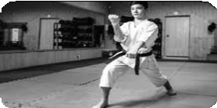
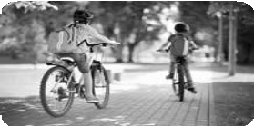
Look and write what the children are doing.
5

1.
2.
3.
4.
4

Put the dialogue in order. Write (1-7).
6
- Yes, that’s right. But I like it here in the UK. How often do you come to the ice-skating rink?
- From the USA.
- Wow! I come twice a week too. On Mondays and Fridays.
- Hello, I’m John.
- Oh, so you’re American!
- Well, I come twice a week. On Mondays and Thursdays.
- Hi! Where are you from, John?
7

Write about what you always, usually, never do at the weekend.
7
1.
2.
3.
3

